***M.tech Project Progress Report***

**Evaluation of Road Roughness using Smartphone App and comparing it with the MERLIN and Roughometer roughness**

***Submitted in partial fulfillment of the***

***requirement for the award of the degree***

***of***

**MASTERS OF TECHNOLOGY**

***in***

**CIVIL ENGINEERING**

***By***

**PRANAV BARADKAR**

**Roll No.: 17CE02012**

***With the supervision of***

**Dr. Anush K. Chandrappa**



**SCHOOL OF INFRASTRUCTURE**

**INDIAN INSTITUTE OF TECHNOLOGY BHUBANESWAR**

**ARGUL, JATNI -752050, ODISHA**

**SEPTEMBER 2021**

CONTENT

CONTENT i

LIST OF FIGURES ii

CHAPTERS PAGE-NO 1 Introduction 1

1.1 General 1

1.2 Pavement Management system 2

1.3 International Roughness Index. 3

1.4 Problem statement 4

1.5 Objective and scope 5

1.6 Methodology 6

2 Literature Review 8

2.1 General 8

2.2 Road Roughness 8

2.3 Roughness Measurement Methods 9

2.3.1 Profilometric systems 9

2.3.2 Response Type Road Roughness Measuring System (RTRRMS) 14

2.3.3 Accelerometer Based Equipment 17

2.4 Classification of Road Roughness Measuring System 18

2.4.1 Class 1: precision profile 18

2.4.2 Class 2: Other profilometer Methods 19

2.4.3 Class 3: Response type Measurements: 19

2.4.4 Class 4: Subjective Rating 19

2.5 International Road Roughness: 19

2.6 Evaluating International roughness index. 20

2.6.1 Measuring Pavement roughness using Smartphone Application. 21

3 Methods 25

3.1 General 25

3.2 Calculation of reference IRI 25

3.3 Selection of Mobile application. 26

3.4 Estimation of road profile. 28

3.5 Work Plan 29

4 References 30

LIST OF FIGURES

Figure 1.1: Range of IRI on different types of roads. (Source: IRC SP 16 2019) 4

Figure 2.1 Straightedge (source: google) 9

Figure 2.2 Rod and level surveying (source: google) 9

Figure 2.3 Dipstick (source: M. W. Sayers et al. 1998) 9

Figure 2.4 MERLIN device (Source: google) 9

Figure 2.5 Inertial Profiler (source: M.W Sayers, 1998) 9

Figure 2.6 Sketch of fifth wheel bump integrator (source: IRC SP 16 2019) 9

Figure 2.7 Car axle mounted bump integrator (source: IRC SP 16 2019) 9

Figure 2.8 Typical view of a roughometer control panel (source: CSIR) 9

Figure 2.9 QCS model a) vehicle representation b) simplified representation (source: yuchuan du, 2014) 9

Figure 2.10 Correlation between measured IRI and actual IRI (source: Islam, 2014) 9

Figure 2.11 Correlation between IRI and variance a) Samsung mobile 80kmph b) Samsung mobile 64kmph c) Sony mobile 80kmph d) Sony mobile 64kmph. (Source: waleed et al. 2018) 9

Figure 2.12 consistency between measured IRI of Samsung J3 and Motorola G6. (source: Hossain 2021) 9

Figure 3.1 List of application (Source: Paul Cahillet al.,2018) 9

Figure 3.2 List of available application a) G-sensor logger b) Accelerometer analyser c) physics toolbox sensor suit d) sensor kinetics pro e) Accelerometer acceleration f) Accelerometer meter (Source: Google Play Store) 9

Figure 3.3 Program to convert vertical acceleration data to road profile 9

Figure 3.4 Vertical acceleration 9

Figure 3.5 Airport pavement profile 9

Figure 3.6 Work plan 9

# Introduction

## General

Continuously increasing the rate of economic and infrastructure development in several countries like India causes an increase in road traffic, leading to road devastation. Also, funding for infrastructure development is not appropriate with increasing maintenance demands, which is one of the primary causes of significant deterioration. It is one of the reasons to study pavement deterioration or roughness. Bumpy rides have been experienced by everyone at some point, whether on a rural road or a city side street. We can say roughness is probably one of the better-understood properties of pavements, both in a qualitative way by the driver or passenger and in a quantitative manner by road engineers. Roughness simply means how smooth or bumpy a road can be, which is an indicator of how comfortable your ride is and the erosion of your vehicle, its fuel efficiency, and the maintenance needs of the road. Studies have suggested that roughness and traffic data can help to understand how rough roads affect fuel efficiency and greenhouse gas emissions. Results show that rougher roads lead to a greater fuel consumption (Suzanne Greene et al., 2013). Rougher road can increase your vehicle operating cost by 4 - 5% (Islam et al., 2014).

The international roughness index (IRI) is the parameter to measure road roughness. The United States National Cooperative Highway Research Program (US-NCHRP) initiated a research project to help agencies improve their use of roughness measuring equipment. The World Bank continued the workto compare or convert data obtained from different countries involved in World Bank projects. Results from the World Bank testing indicated if methods were standardized, most equipment in use could produce practical roughness measures on a single scale. The roughness scale that was defined and tested was named the International Roughness Index. The IRI is used to manage pavements, identify specific locations where repairs or improvements are recommended, and a key determinant of vehicle operating costs used to determine the economic viability of road improvement projects.

The IRI was defined as a mathematical property of a two-dimensional road profile (a longitudinal slice of the road showing elevation as it varies with longitudinal distance along a traveled track on the road). As such, IRI can be evaluated from profiles obtained from any valid measurement method, ranging from Dipstick surveying equipment to high-speed inertial profiling systems.

Pavement Management System (PMS) tool helps to allocate the budget and available resources for the reconstruction and maintenance for pavements in many countries optimally. The international roughness index (IRI) is considered a critical pavement condition parameter along with other pavement distresses like pavement condition index (PCI), rut depth, and pavement service ability index (PSI).

## Pavement Management system

A pavement management system (PMS) is a managing tool used to make pavement management decisions. PMS software programs predict future pavement deterioration due to traffic and weather and recommend maintenance and repairs to the road's pavement based on the pavement's type, age, and existing pavement quality. Measurements can be made manually by persons on the ground or using automated sensors mounted to a vehicle. PMS software often creates composite pavement quality rankings based on pavement quality measures on-road sections, and results are more biased towards predictive measures rather than reconstruction of the pavement.

Typical tasks performed by pavement management systems include:

1. Inventory of different pavement conditions, identifying good, fair and poor pavements.
2. Assign importance ratings for road segments, based on traffic volumes, road functional class, and community demand.
3. Schedule maintenance of good roads to keep them in good condition.
4. Schedule repairs of poor and fair pavements as remaining available funding allows.

Research has shown that it is expensive to repair a road once it has deteriorated than it's maintenance in good condition. This is why pavement management systems place the priority on preventive maintenance of roads in good condition, rather than reconstructing roads in poor condition.

## International Roughness Index.

In order to address specifics of roughness measurement, or issues of accuracy, it is first necessary to define the roughness scale. In the interest of encouraging use of a common roughness measure in all significant projects throughout the world, an International Roughness Index (IRI) has been selected. The IRI is so-named because it was a product of the International Road Roughness Experiment (IRRE), conducted by research teams from Brazil, England, France, the United States, and Belgium for the purpose of identifying such an index. IRRE was held in Brazilia in Brazil under controlled measurement of different road surfaces under different road conditions using and various roughness measurement devices. The roughness scale selected as a IRI was best suitable for criteria of being relevant, transportable, and time-stable, while also easily used by practitioners.

The IRI is a standardized roughness measurement related to those obtained by response-type road roughness measurement systems (RTRRMS), with recommended units: meters per kilometre (m/km). The measure called by RTRRMS is also called by Average Rectified Slope (ARS) which is measure of average accumulated suspension motion of a vehicle divided by the distance travelled by the vehicle during the test. Reference RTRRMS used for the computation of IRI is a mathematical model in place of mechanical model and this model applied to road profile. The computational mathematical model is called as a quarter-car simulation (QCS) because it represents a RTRRMS having a single wheel. The measure is obtained from the simulation is called reference ARS. ARS is speed dependent therefore a standard speed of 80kmph is specified in IRI definition. The IRI is directly related to the opinions about road roughness. Figure 1.1 shows the range of IRI on different types of roads.

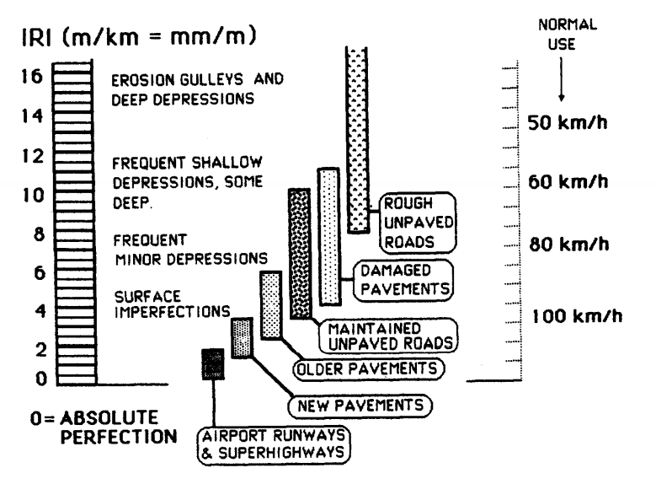

Figure 1.1: Range of IRI on different types of roads. (Source: IRC SP 16 2019)

## Problem statement

A high level of profile variation can increase vehicle operating cost by 4%-6%. Increasing population requires greater vehicular needs and therefore it is necessary to talk about maintenance of pavements and the economic losses due to road roughness.

According to U.S. federation, each state needs to have his own PMS system. PMS help to allocate available resources for maintenance optimally. IRI is consider as very critical parameter for calculation of PMS.

One study reported pavement profile data collection and analysis involve agency costs in the range of $2.23 to $10.00 per mile with an average cost of $6.12 per mile (Islam 2014). In U.S., the cost of measuring IRI varies in the range of $1.40– $6.20 per kilometre (McGhee 2004) and in some areas like Wyoming, the cost of collecting roughness and video logs of pavement sections is around $31 per kilometre. However, many are relying on the IRI for the maintenance and reconstruction of the pavements.

On the other hand, methods which are used for determining IRI are either time consuming or expensive. Therefore, it is necessary to study about different methods which consume less time and cost. Inertial Profiler is one type of high speed profilometer based roughness measuring instruments which is used to calculate IRI at higher speeds. Inertial Profiler finds road profile using laser and vertical acceleration and converts it to IRI. A main drawback of the inertial profiler is that its operating and maintenance costs are very high.

The use of smartphones appears to be an appealing approach for reducing the cost of measuring roads roughness. These smartphones are equipped with many useful sensors such as gyroscopes, global positioning system (GPS), and three-dimensional (3D), or three-axis, accelerometers. But the calibration and validation of roughness data using smartphone is under investigation. Although, there is several road roughness measuring applications available in the smartphones, there sensitivity to changes in vehicle characteristics such as tyre pressure, speed and location of smartphones is not full explored. In this study, ability and consistency of smartphones data to calculate the IRI will be been investigated considering vehicle characteristics and location

## Objective and scope

The present research was focused on calibration and validation of roughness data using smartphone application. The broad objectives of the research are:

1. Calculation of the IRI using the smartphone application.
2. Effect of tire pressure on road roughness in RTRRMS methods.
3. Estimating best position to place smartphone.
4. Validation of smartphones for different pavement materials.

To accomplish the research objective, the scope of research was established, which included

1. Selection of stretch of pavement as study area (Flexible and Rigid Pavement).
2. Data collection using class 1 method.
3. Data collection using a smartphone.
4. Determining profile of the road using a smartphone.
5. Developing a program to calculate IRI from Class-1 data
6. Determining IRI using a smartphone.
7. Calibration and validation of roughness data.
8. Effect of tire pressure.
9. Effect of smartphone positioning.
10. Effect of smartphone type.
11. Effect of Time of the day

## Methodology

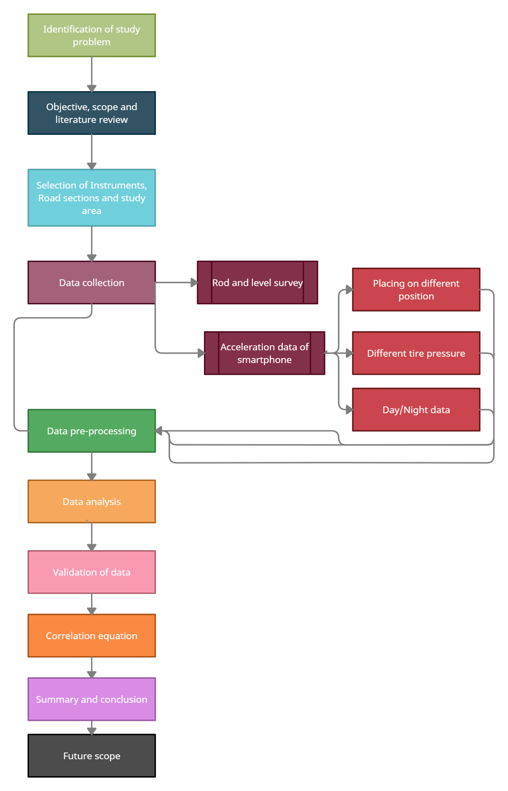

Figure 1.2 Methodology of the research work

The project methodology describes the overall flow of the thesis. The research methodology begins with problem identification and fixing the objective and scope which has been already discussed in Chapter Introduction.

1. Selection of the study area consisting of the selection of the road stretches and also selection of the mobile application which is stated in chapter methods.
2. Data collection is related to collect reference IRI using rod and level and acceleration data placing smartphone on different places in vehicle.
3. Next step follows pre-processing of the data using methods like average, moving average and Kalman filters.
4. Data analysis elaborates about detail study of extracted data and build correlation of measured IRI with reference IRI.
5. Validation steps follow validation of the calculated regression model.
6. Conclusion involves summary of the research and future scope which describes future improvements which can be made in context of measuring IRI using mobile device.

# Literature Review

## General

An exhaustive review of the literature was undertaken to comprehend various aspects of road roughness. The literature review begins with the definition of road roughness, the background of the International Roughness Index, and its importance. Following this, a discussion on various methods to calculate road roughness and IRI is presented. This section is followed by a discussion about the merits and demerits of different techniques and the latest research. Multiple investigations of low-cost methods to calculate IRI and several aspects of analyzed data are the farthest section.

## Road Roughness

There is no proper definition for pavement roughness, it is broadly defined as an expression of irregularities in the pavement surface that affects the ride quality of the vehicle. American Society of Testing and Materials (ASTM) defines (E867) roughness as "The deviations of pavement surface from a true planer surface with characteristic dimensions that affect vehicle dynamics, ride quality, dynamic loads and drainage, for example, longitudinal profile, transverse profile and cross slope". However, the drainage and ride quality is unrelated to each other.

Depending on driving speed and vehicle properties, different wave lengths on the surface profile affect differently on the ride quality. Roughness is an important indicator of pavement comfort, riding quality and safety. Generally, following are some reasons which may cause;

* + construction techniques,
  + Traffic loading. (For example, repeated loads in a channelized area may cause pavement distortion by plastic deformation),
  + environment effects,
  + construction material, and
  + Irregularities and non uniform compaction while construction.

Depressions and Cracking causes Short wave length roughness..On the other hand, environmental process in combination with pavement layer properties causes long wave length roughness.

## Roughness Measurement Methods

Roughness measurements are used to

1. Helps in measuring acceptability of repaired or newly constructed pavement section.
2. Important criteria in monitoring pavement management system.
3. Study the condition of specific sites, and
4. Estimating vehicle operating cost.

Several indices are based either on pavement surface profile or response type road roughness measuring devices currently in use to quantify road roughness.

### Profilometric systems

System whose measurements based on the profiles of road are, generally termed as profilometric system. Continuous representation of road profile is used to local defects, road roughness, etc. It involves measuring the profile, filtering the profile and mathematically computing the relevant roughness index.

#### Straightedge

This is the simplest profiling system. It is made up of wood or metal having usual length of 3 meter. The surface deteroriation can be measured by measuring the distance of pavement surface from bottom side of the beam while keeping it on pavement surface. Straightedge had been modified and now it is called as TRRL Beam static profilometer. TRRL has tripod for levelling and wheel to measure the vertical displacement. Figure 2.1 shows 3-meter straightedge.

Pros:

1. It is very cheap
2. Simple
3. Reliable data collection

Cons:

1. It is very time consuming as it covers only 3 meter of pavement surface and requires human efforts to measure the distance of road surface from bottom edge.
2. Very careful readings are required.
3. Inefficient
4. Lower mechanization.

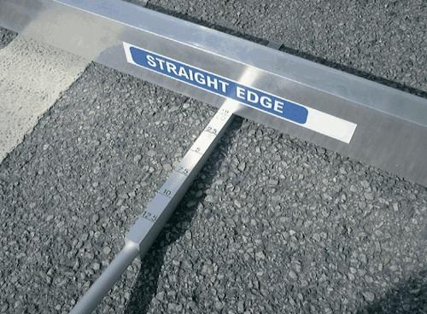

Figure 2.1 Straightedge (source: google)

#### Rod and level

The most well-known equipment to measure profile is with surveying method. The equipment consists of a rod marked with convenient units in ft and cm. a level is used for the reference datum line, and tape is used to measure longitudinal distance along the wheel path. It is generally best when very less profiles are to be measured. Figure 2.2 shows rod and level surveying.

Pros:

1. Better that straightedge in case of time consumption.
2. Time stable.
3. It is very cheap.
4. Gives data to calibrate other high-speed instruments.

Cons:

1. It requires at most 250mm distance between two measuring stations that makes it very slow.
2. Require human efforts.
3. Inconvenient

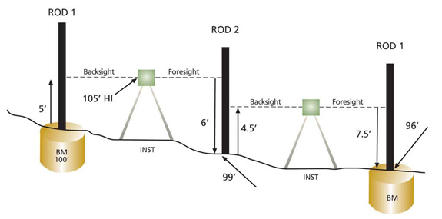

Figure 2.2 Rod and level surveying (source: google)

#### Dipstick

Dipstick contains a precision inclinometer which measure the difference in height between two supports. Dipstick has an accuracy of 0.15mm per reading. To get the profile device s walked along the line being profiled. Figure 2.3 shows a sketch of a dipstick profilometer.

Pros:

1. Better than straightedge and rod and level in case of time consumption.
2. Time stable.
3. Gives data to calibrate other high-speed instruments.

Cons:

1. Costly than rod and level surveying.
2. It covers distance with walking speed it makes it slower for longer pavements.

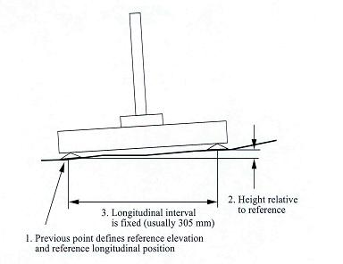

Figure 2.3 Dipstick (source: M. W. Sayers et al. 1998)

#### MERLIN

MERLIN stands for a Machine for Evaluating roughness using low-cost instrumentation. The device can be used for calculating profile or calibrating response type devices. In Sri Lanka, this device is used to calibrate the vehicle-mounted bump integrator. The Merlin was designed by Transport Research Laboratory (U.K.) for using developing countries. Merlin advantages are,

1. Robust – require so special care and handling
2. Easily built
3. Easily calibrated
4. Easily built
5. Easily used
6. Easily maintained
7. Direct reading of IRI is calculated without using the QCS model.

To determine road roughness, usually, 200 measurements are made. The Merlin reading is converted to an IRI scale using the 'Calibration scale.'

The sensitivity of the IRI scale varies with wavelength, and IRI is the highest for waves of around to meter. The sensitivity of the Merlin is also high at these waves. That's why it is reasonable to estimate for IRI. (M.A.Cudil 1996).

Following factors have to be taken into consideration while Merlin is used to taking roughness measurements,

1. Take 200 readings per chart.
2. Take measurements with the wheel in its normal position. These regularly spaced measurements give the most representative result.

Figure 2.4 shows the MERLIN device.

Cons:

1. Inconvenient
2. Inefficient

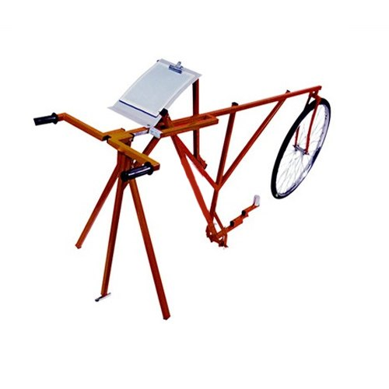

Figure 2.4 MERLIN device (Source: google)

#### Inertial Profiler

This is the most sophisticated road profiling measuring equipment. Inertial profiler consist of sensors like accelerometer and light probes that measures vertical movements of vehicle and road profile data respectively. Data processing algorithms convert the vertical acceleration measure to an inertial reference that defines the height of the accelerometer. This height is measured with a non-contacting sensor. This method of measurements is more accurate and this eliminates many potential sources of human errors. Figure 2.5 shows inertial profiler.

Pros:

1. It is very straightforward.
2. It is high speed instruments that makes it efficient
3. Give direct value of IRI.

Cons:

1. These devices are fitted on a full-size van, automobile, or trailer, it is difficult to use them on the roadway for short periods of time.
2. High cost of operation and maintenance.

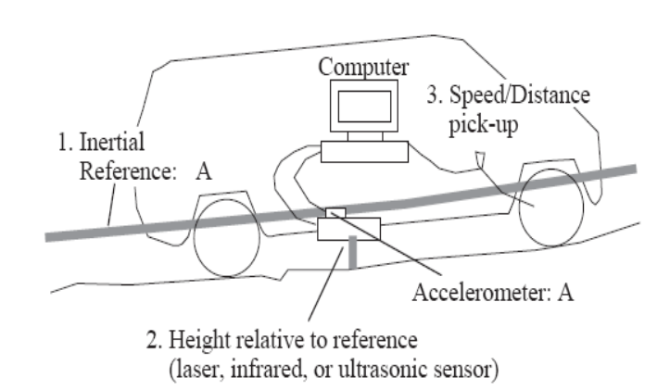

Figure 2.5 Inertial Profiler (source: M.W Sayers, 1998)

### Response Type Road Roughness Measuring System (RTRRMS)

Devices are installed in a car to record the suspension as a measure of road roughness. These are called road meters and several other names called Response-Type Road Roughness Measuring Systems (RTRRMS), response-type systems, and road meter systems. The vehicle is a passenger car, a van, a light truck, or a special trailer in these systems. Nearly the entire road meter designs follow the Bureau of Public Roads (BPR) Rough meter concept and accumulate deflections of the vehicle suspension as it travels down the road. The measure is usually reported with engineering units such as inches per mile (in/mi) or meter per kilometer (m/km).

#### Fifth Wheel Bump Integrator:

As shown in Figure 2.6 Fifth Wheel Bump Integrator is a response roughness measuring system. It consists of a standard pneumatic wheel mounted on chassis with single spiring on either side of the wheel. Integrator makes cumulative measurements of the unidirectional vertical movements of the wheel relative to the chassis. The test is conducted at 32 km/hour, keeping it steady and avoiding swerving. Roughness index is defined as the ratio of the cumulative vertical displacement to the distance traveled and denoted in mm/km unit. The readings of the revolution counter and integrating counters are noted automatically in the datasheet.

Pros:

1. Simple to use.
2. Very fast.
3. Can mount in any vehicle.

Cons:

1. It is not consistent.
2. Time-instable
3. It is affected by vehicle vibrations and weight.
4. Performs at the same speed.
5. High cost for maintenance.

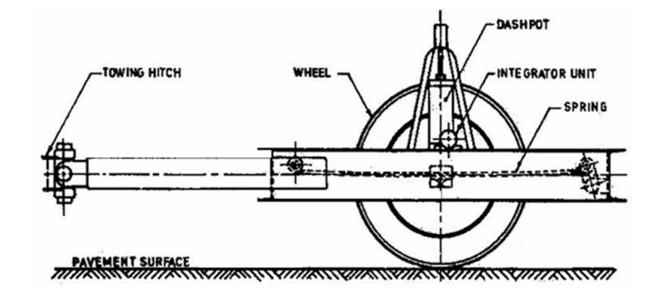

Figure 2.6 Sketch of fifth wheel bump integrator (source: IRC SP 16 2019)

#### Car Axle Mounted Bump Integrator:

The Car axle Mounted Integrator consists of a bump integrator unit as provided in the fifth Bump Integrator, as shown in Figure 2.7. The integrating end is fitted with the rear axle and placed in the back portion of the Car.

The difference of movement of the body of the Car and rear axle due to road unevenness is measured by the upward vertical movement of a wire transmitted into unidirectional rotator movement of the pulley of the integrator unit. The integrating unit converts rotational action into electric pulses, which are recorded into the database. One count represents 1 cm relative movement between floor and axle in 1m length of distance traveled.

Road roughness depends upon the speed of the vehicle, vehicle loads, and outer wheel path. This must be calibrated and validated concerning class-1 equipment as per the standard procedure.

Pros:

1. Simple to use.
2. Very fast.
3. Can mount in any vehicle.

Cons:

1. It is not consistent.
2. Time-instable
3. It is affected by vehicle vibrations and weight.
4. Performs at the same speed.
5. High cost for maintenance.

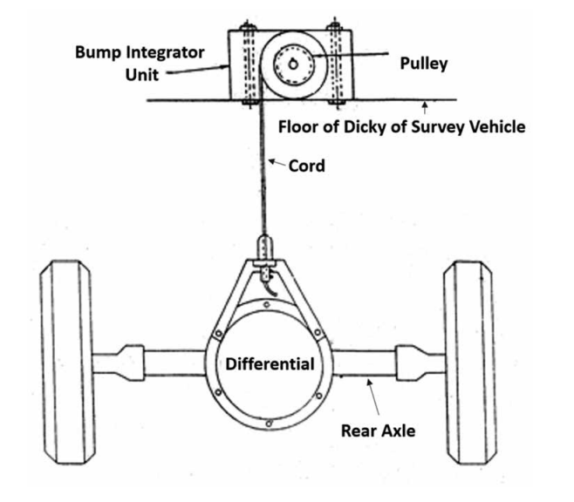

Figure 2.7 Car axle mounted bump integrator (source: IRC SP 16 2019)

### Accelerometer Based Equipment

These systems are based on the mechanism of measurement of vertical acceleration to calculate road roughness. This system may also be validated and calibrated against class- 1 equipment. Some portable type of roughness measuring equipment is available, consisting of a small accelerometer (sensor) device (one or two) installed at the rear axle of the survey vehicle, a distance measuring instrument, an interface module, and a controller.

#### Roughometer

Roughometer is a high-speed device used for measuring pavement surface roughness. It consists of a small accelerometer (sensor) device installed at the rear axle of the survey vehicle, a distance measuring instrument, an interface module, and a controller with the portability feature. The pavement roughness measurements using this equipment must be done preferably at a speed between 40 to 60 km/hr to obtain the most reliable and accurate data. The output is in the units of the International Roughness Index (IRI). Figure 2.8 shows A Typical view of the Roughometer Control Panel with GPS.

Pros:

1. Simple to use.
2. Very fast.
3. Can mount in any vehicle.

Cons:

1. It is not consistent.
2. Time-instable
3. It is affected by vehicle vibrations and weight.
4. Performs at the same speed.
5. High cost for maintenance.
6. Require time to time calibration.

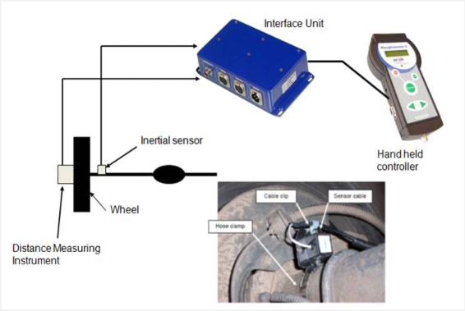

Figure 2.8 Typical view of a roughometer control panel (source: CSIR)

Another device in this category is measurement of IRI using mobile app-based application. This system uses inbuilt GPS and accelerometer to provide IRI of the pavement. Although these systems have self-calibration mechanism but it may be calibrated and validated against Class-1 instruments and also on different pavement types.

## Classification of Road Roughness Measuring System

Instruments used for the collection of roughness data are characterised into four classes.

### Class 1: precision profile

The instruments that provide the highest standard of accuracy for calculating IRI are called as Precision Profilers. This type of instruments provides series of accurately measured elevation points, closely spaced along the section not more than 250 mm with precision less than 0.5mm. for walking speed profilometer. But High speed profilometer have sampling interval is less than 25mm with precision less than 0.1mm.

### Class 2: Other profilometer Methods

An instrument which is not capable of giving accuracy as Class 1 or sampling intervals meet the criteria of class 2. The class 2 sampling intervals are set at a maximum of 500 mm with precision not less than 1mm for walking speed and interval of greater than 25 mm and less than 150 mm with precision not less than 0.2mm.

### Class 3: Response type Measurements:

All Response Type Road Roughness Measuring System (RTRRMS) belongs to this category of roughness measurement. RTRRMSs measure the dynamic response of vehicles to the road surface by using either mechanical or accelerometer devices. The estimation of roughness index for RTRRMS is made using correlation equation after calibration with Class-1 Road profiler.

### Class 4: Subjective Rating

In this class the evaluation of roughness investigated by driving the Car on the road or making the visual survey.

## International Road Roughness:

International roughness index (IRI) is the accepted standard for measuring road surface's roughness in worldwide. The IRI was obtained by the experiment led in Brazil. This experimental helped in comparing direct data of different countries and different instruments that helps in predicting historical trend with confidence. Results from research could not be compared without the use of conversion factors or a common method for calculation,. IRI is reproducible, portable and stable with time. Accordingly, IRI is considered a geometric property of the road. Hence, it is a time-stable index, which generates the same values when applied to the same road (Sayers and Karamihas 1995)

The IRI was mainly developed to match the response of passenger car, but research has shown that IRI is also depending on other vehicles type such as light trucks and heavy trucks. IRI is highly correlated to three vehicle response variables;

1. Road meter response
2. Vertical passenger acceleration, and
3. Vehicle load.

The IRI is a mathematical model applied to measure profile. This model simulates a quarter car system (QCS) traveling at a constant speed of 80Km/hr. The IRI is computed as the cumulative movement of the suspension of the QCS divided by the travelled distance, the unit of the index is m/km. Figure shows the QCS model.

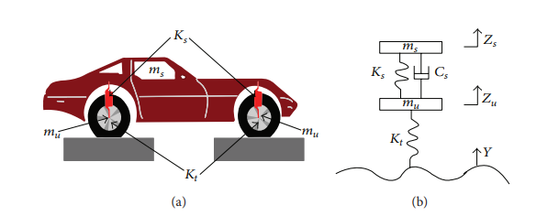

Figure 2.9 QCS model a) vehicle representation b) simplified representation (source: yuchuan du, 2014)

As stated by Sayers (1995):

1. From a solitary longitudinal profile might be processed. The specimen interim ought to be no bigger than 300 mm for exact figuring. The obliged determination is reliant on the roughness level and for smooth streets better determination is required.
2. It's assumed that between sampled elevation point a constant slope persists. By using the method of moving average the profile of base length 250mm.
3. Quarter car simulation is used to filter the smoothed profile, with Car at a simulated speed of 80km/hr (49.7 m/hr).
4. IRI is calculated by direct amassing of mimicked suspension movement which is partitioned by the profile length. Thus, IRI is measured with units in/mi or m/km

## Evaluating International roughness index.

International roughness index is very critical parameter for pavement management system. A high level of profile variation (i.e., roughness) can also increase vehicle operating cost by 4–5% (Islam and Buttlar 2012).

Class 1 and class 2 type instruments provide most accurate reading of the roughness but those are very time consuming and inefficient. In the 1920s, a vehicle's vibrations caused by road surface irregularities became a major concern of highway engineers in identifying road roughness. This led to the development of response-type road roughness meters (RTRRMs). These devices measure vertical displacements in the rear axle of a vehicle. One of the major drawbacks of RTRRMs is that they are highly affected by the performance (particularly the suspension) of the vehicle that is used in the measuring process. These devices were not able to provide time-stable measurements. Hence, they were not comparable and not practical to be used for pavement management purposes (Gillespie 1992).

Nowadays consultants are using most modern roughness measurements devices which are noncontact profile measuring system (Islam et al. 2014). This devices measure deviation is longitudinal profile using acoustic and laser. Then these profiles are passed through software to calculate the IRI. Cost of operation of inertial profile varies from $1.4 - $6.2 per kilometre ((McGhee 2004) and in some cities like Wyoming, the cost of collecting roughness and video logs of pavement sections is around $31 per kilometre. However, many state department of transportations (DOTs) rely on IRI for their roadways' maintenance and rehabilitation planning (Islam et al. 2014). Acceleration based instruments like roughometer have less maintenance and operation cost than inertial profiler but they are still high for developing countries and inconvenient because they need to perform at constant speed.

### Measuring Pavement roughness using Smartphone Application.

Modern smartphones are equipped with many useful sensors such as accelerometer, gyroscope, magnetometer and GPS. These sensors are usually used to identify the orientation of the smartphone screen and other functional activities (Douangphachanh and Oneyama 2013). A 3D accelerometer is a sensor that measures the changes in velocity among the x-, y-, and z-axes in the units of acceleration. Several studies were performed to use 3D accelerometers in identifying roadway conditions (Strazdins et al. 2011; Douangphachanh and Oneyama 2013; Jiménez and Matout 2014; Hanson et al. 2014; Islam et al. 2014, Waleed Aleaadelat 2018). In 2011, Strazdins performed research which states the use of android smartphones to detect potholes and bumps present in pavement. Even with the less accurate accelerometer and GPS they could detect potholes and bumps using simple algorithm.

In 2007 **A. Gonzalez** conducted study to use vehicle accelerometer's acceleration data to estimates road roughness. They harnessed the data from vehicle accelerometer then PSD of the road profile was estimated from the PSD of the axle or body acceleration measurement. But this approach required prior knowledge of vehicle transformation function. Estimated profile then passed through QCS model to propose classification method to road roughness, speed, vehicle parameter and noise. However, this study did not give direct measure of IRI but it was able to output different level of roughness.

**Douangphachanh and Oneyama** conducted a study to estimate the IRI through smartphone accelerometer measurements (Douangphachanh and Oneyama 2013). They used two Android smartphones (Samsung Galaxy Note II and III) mounted on the dashboard of the test vehicle. Two vehicles, a Toyota VIGO 4WD pickup truck and a Toyota Camry were used in this experiment. The IRI was measured using Vehicle Intelligent Monitoring System (VIMS) for every 100 m (328.08 ft). A Fast Fourier Transform (FFT) was performed on the accelerometer data to obtain a frequency domain view of each signal. A linear relationship was established between the sum of magnitudes from FFT and the measured IRI. The resulting relationship was statistically significant when the speed was less than 60 km/h , with a partial dependence on the vehicle and smartphone type. After one year Jiménez and Matout (2014) used tablet's accelerometer to evaluate pavement roughness. In there study they found that vertical acceleration normalized by the driving speed can give indication of the road roughness. However, the study did not develop direct relationship to find IRI but it was able to output different level of roughness.

In the same year, Islam et al. (2014) conducted a study at the University of Illinois to determine the IRI using a smartphones' integrated accelerometers. Three test sites (each 3.22 km long) with various roughness conditions were selected. A perceived road profile was formed by using a double integration method on the vertical acceleration data obtained by the smartphones. The perceived road profile was converted to IRI using ProVAL software. It was found that the calculated IRI values were consistent with the measured IRI values using a standard inertial profiler. However, calibration was required for rougher pavement sections to overcome the effect of suspension damping. Figure 2.10 shows the correlation between IRI by smartphone and reference IRI.

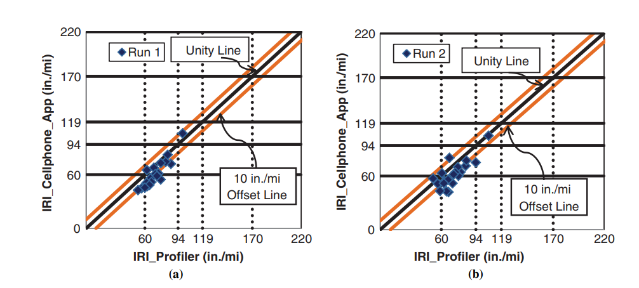

Figure 2.10 Correlation between measured IRI and actual IRI (source: Islam, 2014)

In 2018, **Waleed** conducted a study to calculate IRI on the basis of similar pavement condition may provide similar signal pattern (time acceleration series) using smartphone application. For this study two smartphones Samsung Galaxy SIII and Sony Xperia A were used to collect acceleration data. Phones were mounted on 2011 Ford Fusion sedan dashboard. Twenty random roadway segments were randomly selected from the Wyoming local county roads. Test vehicle is dived at the speed of 80km/h and 64km/hr and accelerometer data collected using AndroSensor application.

Acceleration signal data were pre-processed by applying both median filter with window size 5 and moving average filter with window size 10 to reduce noise in acceleration data. Different pattern recognition techniques like cross-correlation and autocorrelation were applied to find similarities or key features between measured signals at each roughness category. Cross-correlation shows the measured signals (time series acceleration data) using smartphones accelerometers are highly similar in shape. The actual IRI values do not affect the shape of the measured signals meaningfully. Correlation between the variance of acceleration signal and reference IRI gave some promising results. However, results were unsuitable for lower IRI and higher IRI values, as shown in Figure 2.11. Significant differences were seen in the calculated IRI values of both smartphones. This study did not provide any reason for the inconsistency of the data of two smartphones, and vibrations due to car suspension was not normalized.

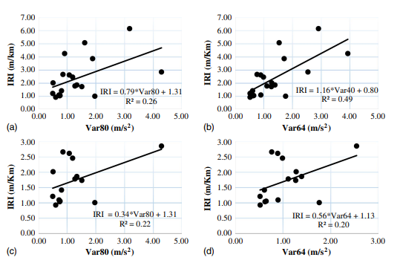

Figure 2.11 Correlation between IRI and variance a) Samsung mobile 80kmph b) Samsung mobile 64kmph c) Sony mobile 80kmph d) Sony mobile 64kmph. (Source: waleed et al. 2018)

In 2021, Hossain conducted a study to check the consistency of Roadroid application data on different smartphones. Two smartphones were mounted on car dashboard and collected IRI data using Roadroid application. This study shows good consistency of IRI in between Samsung and Motorola with R^2 value equal to 0.8. However, the consistency of IRI with PCI value shows an improper relationship. Figure 2.12 shows the consistency between the measured IRI of Samsung J3 and Motorola G6.

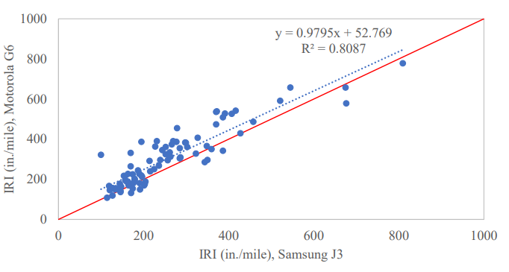

Figure 2.12 consistency between measured IRI of Samsung J3 and Motorola G6. (source: Hossain 2021)

# Methods

This section defines preliminary work which is required for the research consisting of methods and materials used. Initially, It gives a general overview following its selection of mobile phones and applications are discussed. Then, the explanation is given for performing rod and level surveys. In the last section placing of the smartphone has been discussed.

## General

Every research work needs some preliminary understanding and outline methods and material requirements to collect the appropriate data. In this research, placing the mobile phones, selecting an application, and reference IRI of the road plays a crucial role, as stated below.

## Calculation of reference IRI

Reference data plays a crucial role in validating the findings of the research. To get the reference data Rod and level surveying is used in this research.

The most well-known equipment to measure profile is with surveying method. The equipment consists of a rod marked with convenient units in ft and cm. a level is used for the reference datum line, and tape is used to measure longitudinal distance along the wheel path. It is generally best when very less profiles are to be measured. Overview of the procedure used to calculate reference IRI is mentioned below.

* Road stretch of length 400 meters is selected.
* Points are marked on the road along the wheelpath at a 25 cm interval.
* Auto level has been set up exactly vertical using tripod and bubble level attached to it.
* Auto level is used to measure the datum line of the rod.
* Rod is kept at the marked points and rod level is measured using Auto level instrument.
* The first reading taken after the level is set up, is referred to as a backsight, while the last reading taken at that setup before the level is moved, is referred to as a foresight.
* After taking all the readings, equation 1,2,3 is used to find elevation of the selected points.

Instrument Height (IS) = BM + RPI

Relative Elevation of a Point = IS – PR

IS = Initial instrument height,

BM = Elevation of point where first backsight was taken (assume any value e.g. 30 m),

RR1 = Rod reading at first backsight, and

RR = Rod reading at any point from initial instrument setup.

Once position of level is changed, instrument height will also change. New instrument height can be obtained from the following equation:

Nht = Oht + BS – FS

Where:

Nht = New instrument height,

Oht = OLd instrument height,

BS = Backsight at pivot point, and

FS = Foresight at pivot point.

The relative elevation of the points measured from this new instrument location can be determined by using equation 4.2 and using new the instrument height (Nht) instead of IS.

* Measured profile is passed through IRI program to find the reference IRI of the selected road.

## Selection of Mobile application.

**Paul Cahill** et al.,2018 study compared mobile accelerometer application for structural vibrational monitoring. The performance of the application was compared using variance technique and carried test of significance. The apps were compared with realistic dynamic scenario of measuring the acceleration. Data storage facility, tri-axial capability and static calibration of G-force conditions are applied to select 12 apps from 90 available applications. Accuracy of the selected 12 apps are nearly same. Figure shows the list of application suggested to use.

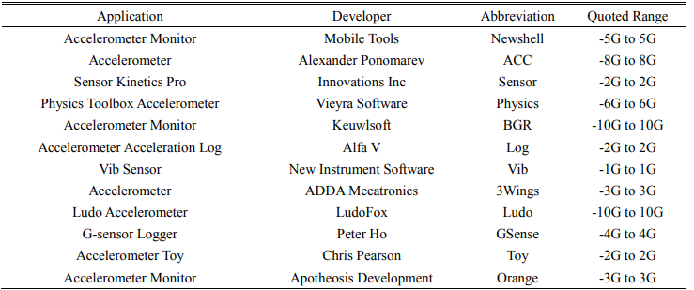

Figure 3.1 List of application (Source: Paul Cahillet al.,2018)

Figure 3.2 shows the application with their current play store rating.

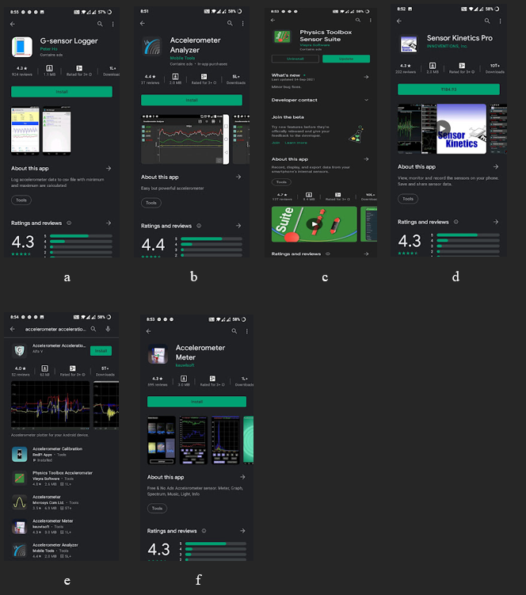

Figure 3.2 List of available application a) G-sensor logger b) Accelerometer analyser c) physics toolbox sensor suit d) sensor kinetics pro e) Accelerometer acceleration f) Accelerometer meter (Source: Google Play Store)

The google play store rating and reviews are taken into consideration to select top 4 applications to do the required study.

1. Physics toolbox sensor suite.
2. Sensor kinetics pro.
3. Accelerometer analyser.
4. G-sensor logger.

## Estimation of road profile.

Double integration of acceleration provides displacement. Figure 3.3 shows python program to converts vertical acceleration data of to road profile.

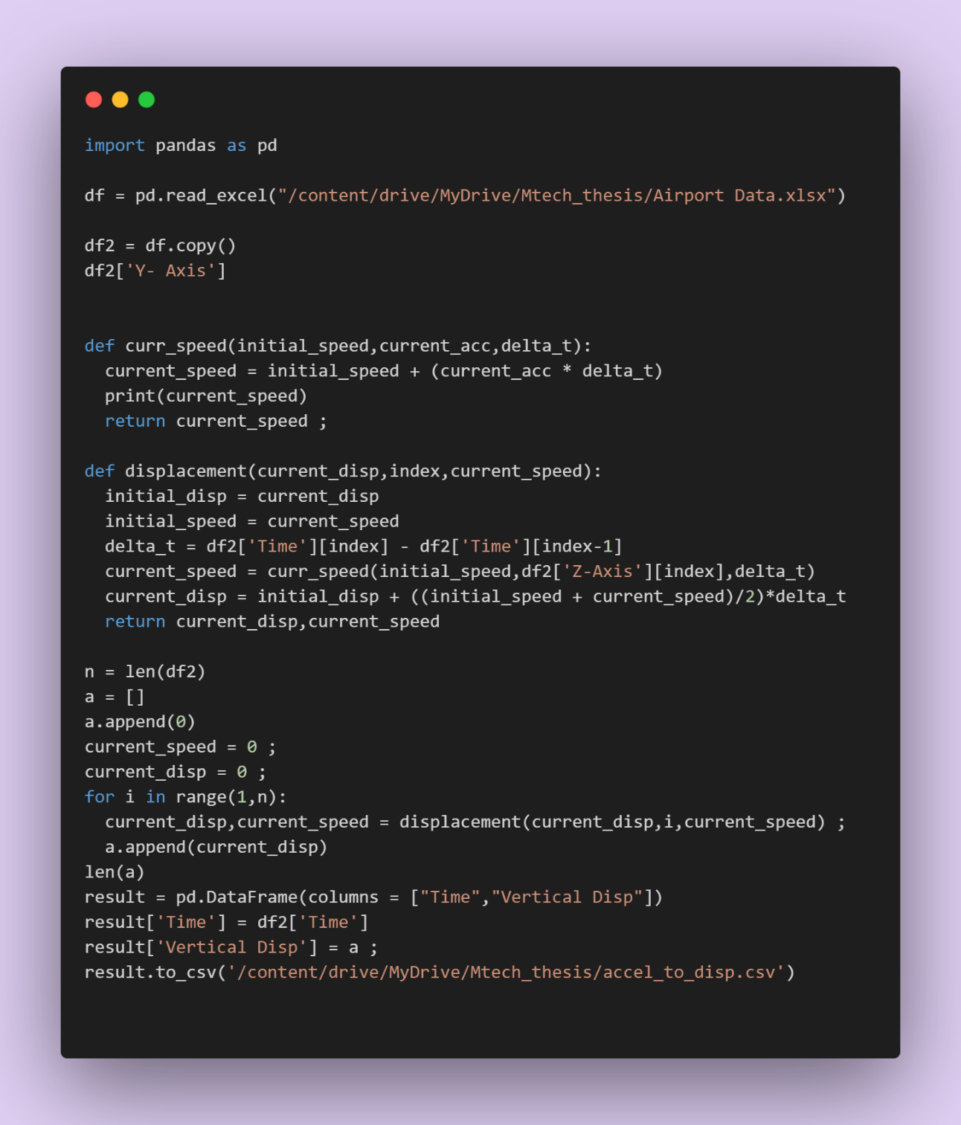

Figure 3.3 Program to convert vertical acceleration data to road profile

To test the above program vertical acceleration data of airport is taken and road profile is evaluated. Figure 3.4 acceleration data and Figure 3.4 shows road profile.

Figure 3.4 Vertical acceleration

Figure 3.5 Airport pavement profile

## Work Plan

Figure 3.6 shows the work plan.

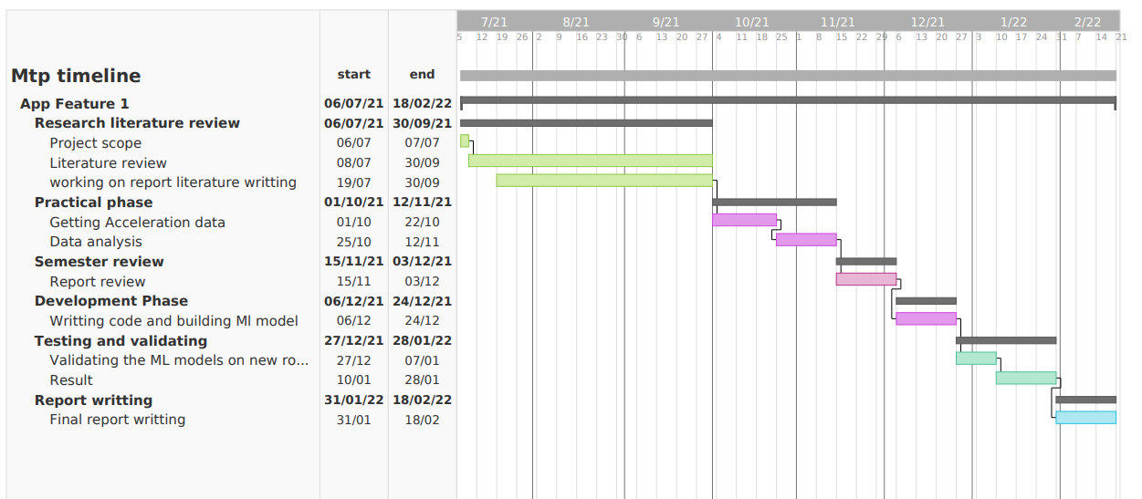

Figure 3.6 Work plan

# References

1. Guidelines on measuring road roughness and norms. IRC SP 16:2019.
2. Mohammad Hossain, Kerrie Schattler (2021). "Evaluation of International Roughness Index Measurement Using Cell Phone App and Compare with Pavement Condition Index" Airfield and Highway Pavements 2021, Page No. 317- 327.
3. Aleadelat, W., Ksaibati, K., Wright, C. H. G., and Saha, P. (2018). "Evaluation of Pavement Roughness Using an Android-Based Smartphone." Journal of Transportation Engineering, Part B: Pavement, 144(3), 1–9.
4. Douangphachanh, V., and Oneyama, H. (2014). "A Model for the Estimation of Road Roughness Condition from Sensor Data Collected by Android Smartphones." Journal of Japan Society of Civil Engineers, Ser. D3 (Infrastructure Planning and Management), 70(5), 103–11.
5. Islam, S., Buttlar, W., Aldunate, R., and Vavrik, W. (2014). "Measurement of Pavement Roughness Using Android-Based Smartphone Application." Transportation Research Record: Journal of the Transportation Research Board, 2457, 30–38.
6. Sayers, M. W., and Karamihas, S. M. (1998). The Little Book of Profiling: Basic Information about Measuring and Interpreting Road Profiles. University of Michigan, Ann Arbor, Michigan.
7. World bank technical paper 46. "Guidelines for conducting and calibrating road roughness measurements". Michael W: Sayers, Thomas D. Gillespie, and William D. O. Paterson.
8. A. González , E.J. O'brien , Y.-Y. Li & K. Cashell (2008) The use of vehicle acceleration measurements to estimate road roughness, Vehicle System Dynamics: International Journal of Vehicle Mechanics and Mobility, 46:6, 483-499.
9. McGhee, K. H. 2004. NCHRP synthesis 334: Automated pavement distress collection techniques. Washington, DC: Transportation Research Board of the National Academies.
10. Strazdins, G., A. Mednis, G. Kanonirs, R. Zviedris, and L. Selavo. 2011. "Towards vehicular sensor networks with android smartphones for road surface monitoring." In Proc., Second Int. Workshop on Networks of Cooperating Objects (CONET'11): Electronic Proc., CPSWeek'11, 1–4. Chicago.
11. Yuchuan Du, Chenglong Liu, Difei Wu, and Shengchuan Jiang, 2014. "Measurement of International Roughness Index by Using 𝑍-Axis Accelerometers and G.P." Mathematical Problems in Engineering Volume 2014, Article ID 928980, 10 pages.
12. Paul Cahill , Lucy Quirk , Priyanshu Dewan and Vikram Pakrashi “Comparison of smartphone accelerometer applications for structural vibration monitoring”. Advances in Computational Design, Vol. 4, No. 1 (2019) 001-013
13. Suzanne Greene, Mehdi Akbarian, Frank-Josef Ulm, Jeremy Gregory “Pavement Roughness and Fuel Consumption” Concrete sustainability hub.